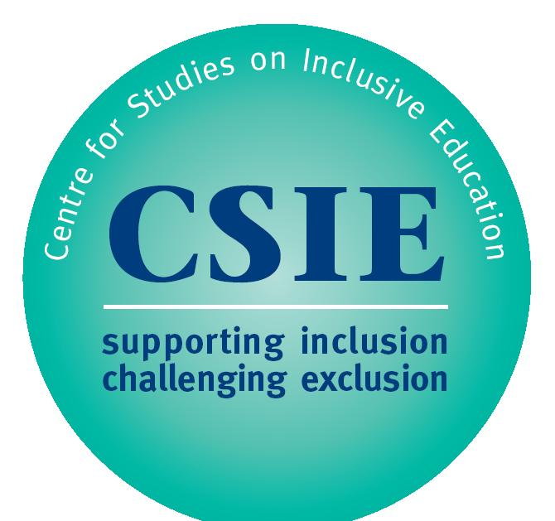

CSIE submission to Education Committee Inquiry into the purpose and quality of education in England

Submitted by Dr Artemi I. Sakellariadis, CSIE director

Executive Summary

CSIE believes that the primary function of education is to enable children and young people to become responsible and informed citizens, capable of sustaining happy and fulfilling lives for themselves and for others. At the heart of this should be an agreed set of core values and a culture of respect for all others, by virtue of being human, as well as for the environment, to enable future generations to establish sustainable communities free from prejudice and discrimination. At a time when information has become easily and readily available, education’s role needs to expand from a conventional learning of facts and skills organised around a range of curriculum subjects, to a more empowering set of life skills relevant as much to information processing as to interpersonal relationships and communication.

Introduction
- The Centre for Studies on Inclusive Education (www.csie.org.uk) is a UK charity working to promote equality and eliminate discrimination in education. CSIE offers training, information, resources and consultancy nationally and internationally. Recent achievements include: publication of Equality: Making It Happen, a “seductively practical” guide for schools sponsored by teachers’ union NASUWT and shortlisted for the European Zero Project award; and contribution to a short film on effects of homophobic bullying, currently used in Ofsted inspector training.

- Founded in 1982, CSIE has been at the forefront of developments in inclusive education for over 30 years. The Centre has a reputation for being at the cutting edge of educational change; staff are regularly invited to speak at conferences or otherwise contribute to a range of events. In the past year CSIE has been invited, among other things, to lead a new national advisory group on Equality, Diversity and Inclusion, to provide a keynote speaker for two conferences in Prague at a key juncture of the Czech Republic’s journey towards a more inclusive education system, and to contribute to an advisory panel for the Standards & Testing Agency of the Department for Education.

Purpose of education
- CSIE believes that the primary function of education is to enable children and young people to become responsible and informed citizens, capable of sustaining happy and fulfilling lives for themselves and for others.
  - Over and above placing young people on any specific career trajectory, CSIE believes that education should equip them with knowledge, skills and confidence to make constructive choices, establish happy and fulfilling lives and make a positive contribution to society.
  - In addition to what is ordinarily taught in schools today, young people need to know more about equality and human rights, for example: to learn more about the Human Rights Act 1998 and the Equality Act 2010 (see also below); to learn more about the UN Convention on the Rights of the Child and other relevant international instruments; and to understand the social model of disability and the prejudices disabled people regularly face, as recommended by the Equality and Human Rights Commission’s 2012report Out in the Open: Tackling disability-related harassment. A manifesto for change. All of this they need to be encouraged, and supported, to put into practice in their school, college or university community.
  - Schools and other education institutions should provide safe spaces and opportunities for respectful discussion. Every opportunity should be taken to challenge stereotypes and educate people away from prejudice.

- Underpinning education should be a set of clearly articulated core values. CSIE suggests that these should include a clear statement about equality and diversity and a crystal clear expectation that respect for all others, by virtue of being human, is non-negotiable.
  - Schools and other educational institutions should be supported to develop a culture of acceptance and respect, where pupils and staff can be open about every aspect of their identity and where nobody feels unsafe, belittled or looked down upon.
  - CSIE is concerned that existing literature on “fundamental British values”, which are described as referring to “democracy, the rule of law, individual liberty, and mutual respect and tolerance of different faiths and beliefs” may serve to undermine the broader remit of the Equality Act 2010 which calls for equality and respect for people who have a wider range of protected characteristics (i.e. not only those who have different faiths and beliefs). CSIE recommends that the Department for Education clarifies its commitment to equality and issues more constructive guidance to schools on addressing all aspects of equality, including socioeconomic background.
  - CSIE is further concerned that league tables and the raising standards agenda are having a negative impact on schools’ willingness to admit disabled pupils or those identified as having special educational needs. Despite national and international legislation stipulating the need to develop a more inclusive education system (for example the Equality Act 2010, the presumption of inclusion in Part III of the Children & Families Act 2014, the UN Convention on the Rights of the Child and the UN Convention on the Rights of Persons with Disabilities) there is growing evidence of schools’ reluctance to admit pupils who are not expected to reach high academic targets. CSIE recommends that the Department for Education clarifies the expectation that schools should serve all members of their local community, especially when parents have requested a place in a particular school (see also 6c below).

- At a time when information has become easily and readily available, education’s role needs to expand from a conventional learning of ever-increasing facts and skills organised around a range of curriculum subjects, to a more empowering set of life skills for critical thinkers and responsible citizens. These skills would be relevant as much to information processing as to interpersonal relationships and communication.
  - Skills relevant to processing information which is readily available would include, for example, how to evaluate the quality and trustworthiness of sources of information, how to seek and consider alternative perspectives or how to use any information accessed responsibly.
  - Skills relevant to interpersonal relationships and communication would include, for example, negotiation and collaboration skills, conflict resolution, healthy relationships including, for older pupils, basic introduction to parenthood, and other life skills such as personal organisation and time management.
  - Additionally, a reformed education system can seek to instil in young people a love of learning as a lifelong pursuit, more than a means to an end.

Quality of education
- The above recommendations necessitate innovative ways of evaluating the quality of education, which go beyond conventional methods focusing on pupils’ academic achievement as a measure of the quality of the provision. CSIE recommends:
  - Using the Equality Act 2010 as an additional framework for evaluating the quality of education. The Public Sector Equality Duty places all schools and other education settings under a statutory duty to: eliminate harassment, discrimination and victimisation; advance equality of opportunity; and foster good relations between people who have and those who do not have the protected characteristics covered by the Act. Implementation, however, is not consistently monitored, nor is there adequate support available for education settings that knowingly or unknowingly are breaching this legislation. This needs to change. The ways in which schools address equality and diversity carried, in the past, far more weight in Ofsted inspections than it does now. CSIE recommends that this balance is redressed and that the implementation of the Public Sector Equality Duty is more consistently and constructively monitored.
  - Evaluating pupil and staff well-being as part of routine processes of evaluating the quality of provision in any education setting. Attempting to measure well-being poses different challenges to attempting to measure learning, nonetheless some standardised instruments are available (for example the well-being measure by the New Philanthropy Capital) and others, potentially more sensitive or more sophisticated, will no doubt be developed when there is sufficient need calling for this.
  - CSIE recommends that, to guard against the continuation of a postcode lottery for pupils who have Education and Health Care Plans (or statements of special educational needs), the Department for Education confirms the national percentage of pupils it expects to be educated in different types of settings. Schools can then be judged on how well they serve their local community, based on their explanation of any differences between their pupils’ progress and the national average expected. In other words, there should be scope within league tables (or other systems which compare attainment results) to value schools’ contribution to the learning of disabled children or those identified as having special educational needs. It should reflect poorly on schools if they appear to be avoiding to admit children who are expected to make slow academic progress, especially if their parents have requested a place in that school. CSIE further recommends that schools’ reluctance to admit particular pupils (for example on the grounds that a school cannot meet a child’s needs) should also be recorded and reviewed as part of schools’ inspection processes.

In 2014 CSIE published, in collaboration with researchers at the University of Exeter, Contrasting responses to diversity: school placement trends 2007-2013 for all local authorities in England. This is the most recent issue in the ongoing series of reports on school placement Trends (i.e. the proportion of children placed in special schools or other separate settings), the only source of local authority comparative information on school placements for children who have statements of special educational needs. Like other Trends reports before it, it reveals huge variation in the proportion of children regularly sent to special schools in different parts of the country. These differences bear no simple relation to the size of a local authority or its social or geographical characteristics and have been referred to as a postcode lottery.

